Effectiveness and safety of community-based ivermectin interventions for malaria control in Africa: a systematic review and meta-analysis

Muhammed O. Afolabi^{1*}, Boni M. Ale², Emmanuel A. Okpo³, Lawrence A. Nnyanzi⁴, Davies Adeloye^{4*}

Affiliations: ¹London School of Hygiene & Tropical Medicine, London, UK

²Holo Global Health Research Institute, Nairobi, Kenya.

³UK Health Security Agency, Newcastle upon Tyne, UK.

⁴Centre for Population Health and Healthcare, School of Health and Life Sciences, Teesside University, Middlesbrough, UK.

Correspondences:

Muhammed O. Afolabi, London School of Hygiene & Tropical Medicine, London, UK. E-mail: Muhammed.Afolabi@lshtm.ac.uk

Davies Adeloye, Centre for Population Health and Healthcare, School of Health and Life Sciences, Teesside University, Middlesbrough, UK. E-mail: D.Adeloye@tees.ac.uk.

Summary

Background
Malaria control progress has stalled in many sub-Saharan Africa (SSA) settings despite widespread deployment of existing prevention and treatment strategies. Ivermectin has emerged as a potential transmission-modifying intervention, but evidence of its effectiveness remains uncertain. We conducted a systematic review and meta-analysis to evaluate its effects on malaria epidemiological, entomological, and safety outcomes in African settings.

Methods
We systematically searched PubMed, Ovid Embase, CENTRAL, ClinicalTrials.gov, WHO International Clinical Trials Registry Platform (ICTRP), and the Pan African Clinical Trial Registry for eligible African studies evaluating ivermectin alone or combined with antimalarial interventions. Random-effects meta-analysis using Restricted Maximum Likelihood estimation was conducted for outcome-specific pooled analyses. Multilevel meta-analysis, robust variance estimation, and Bayesian sensitivity analyses were additionally performed to account for correlated outcomes and reconstructed variance structures.

Findings
Twelve studies contributed 197 outcome-timepoint estimates, including 175 post-intervention estimates. Malaria incidence or infection outcomes showed modest reduction in malaria burden associated with ivermectin-based interventions (risk ratio, RR 0·93, 95% confidence interval, CI 0·85–1·02), although effects varied across intervention settings and implementation strategies. Entomological outcomes demonstrated the strongest intervention effects, with mosquito mortality substantially reduced following ivermectin exposure (RtR 0·59, 95% CI 0·54–0·64), while entomological inoculation rate outcomes also favoured ivermectin interventions (rate ratio, RtR 0·58, 95% CI 0·35–0·96). Mosquito survival outcomes similarly demonstrated reduced vector survival potential (RtR 0·77, 95% CI 0·58–1·01). Serious adverse events or deaths were not clearly increased (RR 1·05, 95% CI 0·74–1·48), but any adverse events were more frequently reported among ivermectin recipients (RR 1.47, 95% CI 1.04–2.10).

Interpretation
Community-based ivermectin interventions consistently reduced entomological transmission indicators, although evidence for direct epidemiological benefit remained modest and context-dependent. These findings support ivermectin as a complementary transmission-modifying intervention rather than a standalone malaria elimination strategy.

Funding
None.

Research in context

Evidence before this study
We searched PubMed, Ovid Embase, CENTRAL, ClinicalTrials.gov, WHO International Clinical Trials Registry Platform (ICTRP), and the Pan African Clinical Trial Registry for studies published from database inception to February 2026, evaluating ivermectin-based interventions for malaria control in Africa. Previous studies and reviews suggested that ivermectin can reduce mosquito survival and vector competence following blood feeding, but evidence regarding population-level malaria reduction remained inconsistent. Most previous syntheses focused either on entomological outcomes or narrative summaries and did not comprehensively integrate epidemiological, entomological, operational, and safety outcomes. Recent large cluster-randomised trials, including BOHEMIA and MATAMAL, have further expanded the evidence base but produced heterogeneous epidemiological findings.

Added value of this study
This study provides a comprehensive quantitative synthesis of ivermectin-based malaria interventions conducted in African settings to date. Unlike previous reviews, we incorporated outcome-specific harmonisation, reconstruction of partially reported variance structures, multilevel meta-analysis, robust variance estimation, and Bayesian sensitivity analyses. The findings demonstrate consistent suppression of entomological transmission indicators, particularly mosquito mortality and entomological inoculation rate, while epidemiological effects remained modest, heterogeneous and context-dependent. The review additionally integrates entomological evidence, epidemiological outcomes, operational implementation findings, and safety data within a unified inferential framework.

Implications of all the available evidence
The available evidence suggests that ivermectin is unlikely to function as a standalone malaria elimination strategy but may provide important complementary value as a transmission-modifying intervention, particularly in settings characterised by residual transmission or insecticide resistance. Repeated dosing strategies, high community coverage, and integration with existing malaria control programmes may be necessary to achieve measurable population-level epidemiological impact. Future trials should prioritise harmonised outcome reporting, standardised variance reporting, and integrated epidemiological-entomological measurement frameworks.

Introduction
Despite substantial progress in malaria prevention and treatment over the past two decades, malaria remains a major public health challenge across sub-Saharan Africa (SSA).¹ Recent estimates from the 2025 World Health Organization (WHO) world malaria report indicate that the African region continues to account for the overwhelming majority of global malaria cases and deaths, with progress in malaria reduction slowing in several high-burden countries.² Persistent residual transmission, insecticide resistance, outdoor mosquito biting, operational limitations of vector-control programmes, and ecological variability continue to undermine existing malaria control strategies, largely from insecticide-treated nets (ITNs), indoor residual spraying (IRS), seasonal malaria chemoprevention (SMC), and artemisinin-based therapies.^{1,2}
These challenges have renewed interest in complementary vector-control strategies capable of targeting mosquito survival through alternative biological pathways.^{3,4} Ivermectin, a widely used antiparasitic drug with an established safety profile in neglected tropical disease (NTD) programmes, has emerged as one of the most extensively studied endectocides for malaria transmission control.⁵ Following administration to humans, ivermectin can reduce mosquito survival after blood feeding, impair vector longevity, reduce fecundity, and potentially suppress malaria transmission intensity.⁶ Experimental studies, feeding assays, and community-based trials have increasingly evaluated ivermectin as a malaria transmission-modifying intervention, either alone or in combination with antimalarial mass drug administration (MDA) and seasonal malaria chemoprevention strategies.⁷⁻¹⁰ However, the current evidence base remains heterogeneous and difficult to interpret. Existing studies vary substantially in intervention design, ivermectin dosage, treatment frequency, transmission intensity, vector ecology, co-administered malaria interventions, and outcome definitions.^{3,11} Moreover, entomological effects observed in studies do not always translate consistently into measurable reductions in malaria incidence or infection at community level.^{4,11,12} Several studies additionally report incomplete variance structures, repeated measurements, correlated outcomes, and differing entomological methodologies, limiting straightforward synthesis using conventional meta-analytic approaches.^{3,11}
Previous reviews have generally focused either on mechanistic entomological evidence or broad narrative summaries and have not comprehensively integrated epidemiological, entomological, operational, and safety outcomes.^{4,10} This creates an important need for an updated evidence synthesis that incorporates recent large community trials and addresses the methodological complexity of demonstrating the impact of ivermectin in malaria control.^{9,13,14} The primary objective of this systematic review and meta-analysis was to evaluate the effects of community-based ivermectin interventions on malaria epidemiological outcomes in malaria-endemic African settings. Secondary objectives were to assess entomological transmission indicators, safety outcomes, and implementation-related factors, and to explore potential sources of heterogeneity across intervention strategies and transmission settings.

Methods

Study design
The primary research question for this review was: What is the effect of community-wide ivermectin administration, either alone or in combination with antimalarial MDA, compared with placebo, standard malaria control, or alternative intervention strategies, on malaria transmission outcomes in African populations. The review was conducted in accordance with the Preferred Reporting Items for Systematic Reviews and Meta-Analyses (PRISMA) 2020 guideline.¹⁵ The review protocol was prospectively registered in PROSPERO (CRD420251242563). Minor deviations from the original protocol included harmonisation of several sparse entomological endpoints into broader biologically coherent synthesis domains and pooling of selected EIR-related measures where outcome-specific reporting was insufficient for separate meta-analysis.

Eligibility criteria
Studies were eligible for inclusion if they:
(i) evaluated community-wide ivermectin administration in malaria-endemic African settings; (ii) included a comparator arm or comparative counterfactual;
(iii) reported malaria epidemiological, entomological, safety, or operational outcomes;
(iv) involved human populations; and
(v) used experimental, quasi-experimental, cluster-randomised, or comparative interventional designs. Eligible intervention strategies included ivermectin administered alone, ivermectin co-administered with antimalarial MDA regimens such as dihydroartemisinin-piperaquine (DP), ivermectin integrated with SMC programmes, and ivermectin combined with vector-control interventions. Observational studies without a comparative design were retained for contextual narrative synthesis where operationally relevant but were excluded from quantitative pooling unless comparative effect estimates could be reconstructed. Studies exclusively involving laboratory-only mosquito experiments without population-level relevance, modelling-only investigations, pharmacokinetic-only studies, cattle-targeted ivermectin interventions without human administration, and purely descriptive reports without outcome comparators were excluded from the primary synthesis. Full-text exclusion categories are reported in Appendix, Table S2 (p. 5-6).

Search strategy
We conducted literature searches across key databases and trial registries, including PubMed, Ovid Embase, Cochrane CENTRAL, ClinicalTrials.gov, the WHO ICTRP, and the Pan African Clinical Trial Registry. Additional grey literature sources, conference materials, Google Scholar, and reference lists of included studies were searched to identify further eligible studies. The search strategy, terms and free-text keywords are provided in Appendix, Table S1 (p. 5-6).

Data extraction and harmonisation
A structured data extraction framework was developed to capture study-level, intervention-level, and outcome-level characteristics. Extracted variables included study design, country and transmission setting, intervention characteristics, comparator details, co-administered malaria interventions, ivermectin dosing strategy, entomological methods, operational indicators, safety outcomes, effect estimates, confidence intervals, and raw event data where available. Each extraction row represented a single outcome-specific estimate at a defined follow-up timepoint to preserve the hierarchical structure of repeated measurements and multiple correlated outcomes contributed by individual studies. Outcomes were grouped into epidemiological, entomological, and safety domains. Harmonisation procedures, outcome definitions, and effect conversions are described in the Appendix (p. 2-3).

Statistical analysis
Outcome-specific random-effects meta-analyses were conducted using restricted maximum likelihood (REML) estimation to account for expected heterogeneity across intervention platforms, transmission settings, outcome definitions, and study designs. Effect estimates were analysed on the log scale and presented as risk ratios (RRs), rate ratios (RtRs), or equivalent relative effect measures with 95% confidence intervals (CIs). Where estimable, 95% prediction intervals (PIs) were additionally reported to assess the expected range of effects in future comparable settings. Heterogeneity was quantified using τ² and I² statistics. Because several studies contributed repeated measurements, multiple intervention contrasts, and correlated outcomes, three-level multilevel meta-analysis and robust variance estimation (RVE) were used as sensitivity analyses to account for within-study dependence. These analyses assessed the robustness of findings to correlated effect structures and compared uncertainty estimates with the primary REML models.
Bayesian hierarchical models were fitted as additional sensitivity analyses for sparse outcomes and analyses involving reconstructed variance estimates. Weakly informative priors were specified for intervention effects (θ ~ N(0,1)), and posterior distributions were summarised using medians, 95% credible intervals, and posterior probabilities favouring ivermectin-associated reductions in transmission. Exploratory subgroup and meta-regression analyses were conducted to investigate potential sources of heterogeneity, including intervention regimen, co-administered malaria interventions, transmission intensity, follow-up duration, and vector characteristics.
Sensitivity analyses included exclusion of studies at high risk of bias, exclusion of reconstructed estimates, variation in cluster-adjustment assumptions, and leave-one-out analyses. Additional details of multilevel models, RVE analyses, Bayesian methods, meta-regression, influence diagnostics, and sensitivity analyses are provided in the Appendix (Tables S4–S8, S10–S12, p. 14). Certainty of evidence was assessed using the Grading of Recommendations Assessment, Development and Evaluation (GRADE) framework,¹⁶ considering risk of bias, inconsistency, indirectness, imprecision, and publication bias. Entomological and epidemiological outcomes were assessed separately because transmission-related surrogate endpoints may not directly translate into population-level malaria outcomes. Certainty assessments are presented in Table 3 and Table S9 (Appendix, p. 21).
All analyses were conducted in R version 4.5.1 (R Foundation for Statistical Computing, Vienna, Austria), and in Python version 3.12.

Results

Study selection
The search identified 289 records before deduplication. After removal of duplicates, 214 records underwent title and abstract screening, of which 47 were assessed in full text. Twelve studies met eligibility criteria for quantitative synthesis, and five additional studies contributed to the narrative synthesis (Figure 1). Reasons for full-text exclusion are presented in Appendix (Table S2, p. 6). A total of 197 outcome-timepoint estimates were extracted, including 175 post-intervention estimates included in the quantitative synthesis. These comprised 133 entomological, 19 malaria epidemiological, and 23 safety estimates. Study characteristics are summarised in Table 1 and in the Appendix (Table S3a-b, p. 7-13)

Malaria epidemiological outcomes
Nineteen epidemiological estimates from five studies contributed to the primary analysis. Ivermectin-based interventions were associated with a pooled RR of 0.93 (95% CI 0.85–1.02; I²=57.8%; τ²=0.014; prediction interval 0.73–1.19) for malaria incidence or infection (Table 2; Figure 2). Approximate absolute effects are presented in the Appendix (Table S11, p. 14). Additional REML and Bayesian results are provided in Figure 3 and the Appendix (Tables S4–S5, p. 31),

Entomological outcomes
A total of 133 entomological estimates contributed to the synthesis. Mosquito mortality was the most frequently reported outcome (69 estimates from four studies) and yielded a pooled RtR of 0.59 (95% CI 0.54–0.64; I²=97.2%; prediction interval 0.32–1.10) (Table 2; Figure 2). Mosquito survival was reduced following ivermectin exposure (RtR 0.77, 95% CI 0.58–1.01; I²=97.2%; prediction interval 0.23–2.59). Nine estimates from five studies contributed to entomological inoculation rate (EIR) analyses, yielding a pooled RtR of 0.58 (95% CI 0.35–0.96; I²=46.8%; prediction interval 0.20–1.66). Vector density (RtR 0.71, 95% CI 0.48–1.06), sporozoite rate (RtR 0.79, 95% CI 0.58–1.07), human biting rate (RtR 0.92, 95% CI 0.53–1.61), and parity rate (RtR 0.97, 95% CI 0.91–1.02) also favoured ivermectin-based interventions (Table 2). Single-study outcomes showed a marked reduction in mosquito fecundity (RtR 0.07, 95% CI 0.04–0.12) and little difference in blood-feeding proportion (RtR 1.00, 95% CI 0.59–1.72) (Table 2). Additional REML, Bayesian, and influence analyses are presented in Figure 3 and the Appendix (Tables S4–S8, p. 31)

Safety outcomes
Twenty-three safety estimates contributed to the synthesis. Serious adverse events or deaths were not significantly different between intervention and comparator groups (RR 1.05, 95% CI 0.74–1.48) (Table 2; Figure 2). Any adverse events were more frequently reported among ivermectin recipients (RR 1.47, 95% CI 1.04–2.10; I²=68.2%). Other safety outcomes were sparse and imprecisely estimated (RR 3.32, 95% CI 0.91–12.09). Certainty assessments are presented in Table 3 and Appendix (Table S9, p. 21).

Heterogeneity, subgroup and sensitivity analyses
Substantial heterogeneity was observed for several outcomes, particularly mosquito mortality, mosquito survival, parity rate, and malaria incidence/infection (Table 2). Exploratory subgroup and meta-regression analyses identified variation by ivermectin regimen, treatment frequency, co-administered malaria interventions, transmission intensity, follow-up duration, and vector characteristics (Appendix, Table S10, p. 22). Cluster-robust, multilevel, Bayesian, and leave-one-out sensitivity analyses generally supported the primary findings (Appendix, Tables S5–S8 and S12; Figures S3–S6, p. 40).

Discussion

Summary of findings
We found that ivermectin-based community interventions consistently reduced several entomological transmission indicators, particularly mosquito mortality and entomological inoculation rate, supporting a biologically plausible effect on malaria transmission potential. However, evidence for direct population-level malaria reduction was more modest and heterogeneous, with pooled malaria incidence/infection estimates suggesting a small reduction that remained compatible with little or no effect. Entomological outcomes generally demonstrated larger effect sizes than epidemiological outcomes, although several outcomes showed substantial heterogeneity and prediction intervals indicating variability in effects across transmission settings and intervention platforms. The observed heterogeneity is expected for complex vector-control interventions delivered across diverse ecological, entomological, and operational settings and should therefore not be interpreted solely as inconsistency of effect. Prediction intervals include the possibility of little or no effect in some future settings despite statistically significant pooled estimates. Exploratory analyses suggested stronger effects in studies implementing repeated community ivermectin administration than in those layered onto highly effective antimalarial mass drug administration programmes. We observed no increase in serious adverse events or deaths, although mild and transient adverse events were more frequently reported among ivermectin recipients. This evidence suggests that ivermectin may have value as a complementary transmission-modifying intervention, but current evidence remains insufficient to establish consistent population-level malaria reduction across diverse African settings.

Findings in the context of the wider literature
Our findings are consistent with the current positioning of ivermectin as a potential complementary malaria transmission-control tool rather than a replacement for established interventions.^{8,17} WHO has identified endectocide and ectocide products, including ivermectin-based approaches, as candidate tools for reducing malaria transmission, particularly where residual or outdoor transmission is not adequately addressed by insecticide-treated nets and indoor residual spraying.⁵ This is relevant in sub-Saharan Africa, where malaria burden remains high despite major gains from vector control and effective antimalarial treatment.¹ Earlier modelling work showed that malaria interventions substantially reduced infection prevalence and clinical disease across Africa between 2000 and 2015,¹ but more recent estimates from the 2025 world malaria report indicate that progress has slowed and the African region continues to account for most global malaria cases and deaths.²
The stronger effects observed for entomological outcomes in our synthesis are also consistent with the biological rationale for ivermectin. Experimental and field studies have shown that mosquitoes feeding on ivermectin-treated hosts have reduced survivorship, and subsequent work has suggested potential effects on parasite development within mosquitoes.^{10,18} These findings support the plausibility of ivermectin as a systemic vector-control intervention,⁶ but they also highlight an important distinction: reducing mosquito survival or transmission potential does not necessarily guarantee a measurable reduction in malaria incidence in human populations over short follow-up periods.^{11,19}
This distinction is reflected in the wider trial and modelling literature. The ivermectin development roadmap emphasised that epidemiological impact is likely to depend on sustained community exposure, repeated treatment cycles, adequate coverage, appropriate timing relative to transmission season, and careful assessment of safety and operational feasibility.^{3,8} Transmission-dynamic modelling similarly suggests that ivermectin could reduce malaria transmission, but that population-level impact is likely to be sensitive to regimen, coverage, local transmission intensity, and background control measures.¹⁹ This aligns with our finding that entomological outcomes showed stronger and more consistent effects than epidemiological outcomes.
Recent cluster-randomised trials^{9,13,14} further illustrate this context-dependence. The BOHEMIA trial in Kenya reported reductions in malaria infection following repeated community ivermectin administration, supporting the possibility that sustained ivermectin exposure can produce measurable epidemiological benefit under favourable implementation conditions.⁹ By contrast, the Gambian trial of ivermectin combined with dihydroartemisinin-piperaquine was conducted in a setting with high coverage of standard malaria control interventions and showed more complex incremental effects, reinforcing that ivermectin’s added value may be harder to detect when potent antimalarial mass drug administration already suppresses transmission.¹² Taken together, the literature supports a cautious interpretation: ivermectin has a strong entomological rationale and may be useful as an adjunctive transmission-modifying intervention, but its epidemiological effectiveness is likely to depend on local transmission ecology, regimen, coverage, co-interventions, and duration of follow-up.
Our findings are further supported by laboratory and experimental studies that were not eligible for quantitative synthesis. Kobylinski et al.²⁰ demonstrated dose-dependent susceptibility of Anopheles mosquitoes to ivermectin, while livestock-based studies by Pooda et al.,²¹ Sougué et al.²², and Zela et al.²³ showed sustained reductions in mosquito survival and fecundity together with prolonged mosquitocidal activity following ivermectin exposure. Although these studies did not evaluate community-level malaria outcomes and were therefore unsuitable for quantitative pooling, they strengthen the biological plausibility of our findings and highlight the potential of long-acting endectocide formulations to extend vector suppression. Whether these approaches can be translated safely and effectively into human malaria control programmes remains an important priority for future research.

Strengths and limitations
This review provides one of the most comprehensive syntheses of ivermectin-based malaria interventions conducted in Africa to date, integrating evidence from community trials, entomological studies, and safety evaluations. By combining epidemiological, entomological, and safety outcomes, this review provides a broad assessment of ivermectin’s potential role as a malaria transmission-modifying intervention. The use of outcome-specific meta-analyses, multilevel models, robust variance estimation, and Bayesian sensitivity analyses further strengthened assessment of the consistency and robustness of findings. Overall certainty ranged from moderate for major entomological outcomes to low for several epidemiological outcomes because of inconsistency and imprecision.
Several limitations should be considered. First, the evidence base remains relatively small, particularly for epidemiological outcomes, with only five studies contributing pooled malaria incidence or infection estimates. Several outcomes were informed by few studies, and some entomological endpoints were derived from single-study evidence.
Second, substantial heterogeneity existed across intervention platforms, ivermectin regimens, transmission settings, vector ecologies, follow-up periods, and outcome definitions. Although this reflects the diversity of real-world malaria transmission settings, it limits the precision and generalisability of some pooled estimates.
Third, several outcomes required reconstruction of variance measures or cluster-adjusted estimates because of incomplete reporting. Standard errors were reconstructed from reported confidence intervals, p-values, summary statistics, and effective sample size adjustments for cluster-randomised studies using established meta-analytic methods recommended in the Cochrane Handbook and widely applied in evidence synthesis.²⁴⁻²⁷ These procedures enabled inclusion of otherwise unusable data but inevitably introduced additional uncertainty, despite the extensive sensitivity analyses undertaken.
Fourth, entomological outcomes should be interpreted as transmission-related surrogate endpoints rather than direct measures of malaria burden. Although reductions in mosquito survival and transmission potential provide strong biological support for ivermectin’s mechanism of action,^{10,21,22} these effects may not translate directly into measurable reductions in malaria incidence under operational conditions. The limited number of studies also restricted formal assessment of publication bias and prevented definitive conclusions regarding some sparse outcomes. Consequently, while the evidence consistently supports entomological transmission suppression, the magnitude and consistency of population-level malaria reduction remain uncertain and require confirmation in larger, harmonised community trials.

Implications for research, policy and practice
The findings from this synthesis have important implications for malaria control policy, future intervention design, and the development of integrated vector management strategies in sub-Saharan Africa. We note that ivermectin has potential as a complementary malaria transmission-control tool, particularly in settings where residual transmission, outdoor biting, or insecticide resistance limit the effectiveness of conventional vector-control interventions. The consistent reductions observed in mosquito mortality and entomological inoculation rate support the biological rationale for ivermectin as a transmission-modifying intervention and align with growing interest in endectocides within integrated vector management strategies.⁵
However, the available evidence does not support ivermectin as a standalone malaria elimination strategy. Rather, its effectiveness is likely to depend on local transmission ecology, intervention coverage, dosing regimen, timing relative to transmission seasons, and interaction with existing malaria control measures.^{3,19} Future implementation efforts should therefore prioritise settings where additional vector-control approaches are most needed and where potential incremental benefits can be clearly demonstrated.^{3,5}
Several research priorities emerge from this review. First, larger community-based trials with harmonised epidemiological and entomological endpoints are needed to clarify when reductions in vector transmission translate into measurable reductions in malaria burden.^{9,11,14} Second, future studies should improve reporting of intervention coverage, cluster-adjusted estimates, and variance measures to facilitate evidence synthesis and comparison across settings.¹¹ Third, further work is required to optimise dosing strategies, treatment frequency, and formulation development, including evaluation of long-acting endectocide formulations that may prolong mosquitocidal activity while maintaining acceptable safety profiles.^{3,4,22,23}
Future evaluations should also incorporate operational and economic outcomes, including feasibility, acceptability, equity, cost-effectiveness, and long-term programme sustainability.^{28,29} Integrating epidemiological and entomological measurements within future trials will be particularly important for understanding how changes in vector survival and transmission dynamics translate into population-level malaria outcomes.^{4,11} Although epidemiological effects were modest, even small reductions in malaria incidence could have meaningful public health benefits in high-transmission settings where disease burden remains substantial.^{4,30}

Conclusions
The available African evidence suggests that ivermectin-based interventions consistently disrupt entomological transmission processes, particularly mosquito survival and EIR-related outcomes. However, evidence for direct epidemiological malaria reduction remains modest, but biologically coherent, heterogeneous, and context-dependent. Ivermectin therefore appears more appropriately conceptualised as a potentially useful complementary transmission-modifying intervention rather than a standalone malaria elimination strategy. Larger harmonised trials integrating epidemiological and entomological endpoints will be necessary to clarify the settings and implementation conditions under which ivermectin-associated transmission suppression translates into meaningful population-level malaria reduction.
_
Authorship declaration: MOA conceived the study. DA designed the study. DA and MOA conducted the literature searches, screened studies, extracted and reviewed the data, and performed the statistical analyses. BMA developed additional data visualisations. MOA and DA drafted the manuscript, with inputs from EAO and LAN. All authors contributed to the interpretation of the findings, critically revised the manuscript for important intellectual content, approved the final version for publication, and accept responsibility for the integrity and accuracy of the work. All authors had full access to the study data, and there were no restrictions on data access.
Disclosure statement: The authors declare no conflicts of interest.
Funding: None.
Data availability: The underlying datasets are available upon reasonable request addressed to the corresponding author. All R and Python code used for the analysis can be accessed via the GitHub repository: xxx

References

1. Bhatt S, Weiss DJ, Cameron E, et al. The effect of malaria control on Plasmodium falciparum in Africa between 2000 and 2015. Nature 2015; 526(7572): 207-11.
2. World Health Organization. World malaria report 2025: addressing the threat of antimalarial drug resistance. Geneva: World Health Organization; 2025.
3. Billingsley P, Binka F, Chaccour C, et al. A Roadmap for the Development of Ivermectin as a Complementary Malaria Vector Control Tool. Am J Trop Med Hyg 2020; 102(2s): 3-24.
4. Slater HC, Foy BD, Kobylinski K, et al. Ivermectin as a novel complementary malaria control tool to reduce incidence and prevalence: a modelling study. Lancet Infect Dis 2020; 20(4): 498-508.
5. World Health Organization. Endectocide and ectocide products for malaria transmission control: preferred product characteristics: World Health Organization; 2022.
6. Chaccour C, Rabinovich NR. Ivermectin to reduce malaria transmission II. Considerations regarding clinical development pathway. Malar J 2017; 16(1): 166.
7. Foy BD, Alout H, Seaman JA, et al. Efficacy and risk of harms of repeat ivermectin mass drug administrations for control of malaria (RIMDAMAL): a cluster-randomised trial. Lancet 2019; 393(10180): 1517-26.
8. The Ivermectin Roadmappers. A roadmap for the development of ivermectin as a complementary malaria vector control tool. The American Journal of Tropical Medicine and Hygiene 2020; 102(2_Suppl): 3-24.
9. Chaccour C, Maia M, Kariuki M, et al. Ivermectin to Control Malaria - A Cluster-Randomized Trial. N Engl J Med 2025; 393(4): 362-75.
10. Kobylinski KC. The effect of mass drug administration of ivermectin to humans on wild Anopheles gambiae s.s. survivorship. American Journal of Tropical Medicine and Hygiene 2010; 1): 137.
11. de Souza DK, Thomas R, Bradley J, Leyrat C, Boakye DA, Okebe J. Ivermectin treatment in humans for reducing malaria transmission. Cochrane Database Syst Rev 2021; 6(6): Cd013117.
12. Dabira ED, Soumare HM, Conteh B, et al. Mass drug administration of ivermectin and dihydroartemisinin-piperaquine against malaria in settings with high coverage of standard control interventions: a cluster-randomised controlled trial in The Gambia. Lancet Infect Dis 2022; 22(4): 519-28.
13. Somé AF, Somé A, Sougué E, et al. Safety and efficacy of repeat ivermectin mass drug administrations for malaria control (RIMDAMAL II): a phase 3, double-blind, placebo-controlled, cluster-randomised, parallel-group trial. Lancet Infect Dis 2025; 25(7): 737-50.
14. Hutchins H, Pretorius E, Bradley J, et al. Adjunctive ivermectin mass drug administration for malaria control on the Bijagos Archipelago of Guinea-Bissau (MATAMAL): a quadruple-blinded, cluster-randomised, placebo-controlled trial. Lancet Infect Dis 2025; 25(4): 424-34.
15. Page MJ, McKenzie JE, Bossuyt PM, et al. The PRISMA 2020 statement: an updated guideline for reporting systematic reviews. Bmj 2021; 372: n71.
16. Guyatt GH, Oxman AD, Vist GE, et al. GRADE: an emerging consensus on rating quality of evidence and strength of recommendations. BMJ 2008; 336(7650): 924-6.
17. Anonymous. A Prospective Surveillance Study to Detect Antimalarial Drug Resistance, Gene Deletions of Diagnostic Relevance and Genetic Diversity of Plasmodium Falciparum in Mozambique. clinicaltrialsgov 2022; 15.
18. Kobylinski KC, Foy BD, Richardson JH. Ivermectin inhibits and delays the development of plasmodium falciparum in anopheles gambiae. American Journal of Tropical Medicine and Hygiene 2012; 1): 152.
19. Slater HC, Walker PGT, Bousema T, Okell LC, Ghani AC, Drakeley CJ. The potential impact of adding ivermectin to a mass treatment intervention to reduce malaria transmission: a modelling study. The Journal of Infectious Diseases 2014; 210(12): 1972-80.
20. Kobylinski KC, Ubalee R, Ponlawat A, et al. Ivermectin susceptibility and sporontocidal effect in Greater Mekong Subregion Anopheles. Malar J 2017; 16(1): 280.
21. Pooda HS, Rayaisse JB, Hien DF, et al. Administration of ivermectin to peridomestic cattle: a promising approach to target the residual transmission of human malaria. Malar J 2015; 13 Suppl 1: 496.
22. Sougue E, Ouedraogo COW, Some FA, et al. Effect of pharmacokinetically-relevant ivermectin concentrations on survivorship and fecundity of Anopheles coluzzii and Aedes aegypti in Burkina Faso: a laboratory experimental study. bioRxiv 2025; 08.
23. Zela L, Pooda SH, Porciani A, et al. Selection of a Lead Long-Acting Formulation of Ivermectin to Target Major Malaria Vectors in Western Africa: Evaluation of Pharmacokinetics and Mosquitocidal Efficacy in Cattle under Laboratory Conditions. bioRxiv 2025; 26.
24. Hedges LV, Tipton E, Johnson MC. Robust variance estimation in meta-regression with dependent effect size estimates. Research Synthesis Methods 2010; 1(1): 39-65.
25. IntHout J, Ioannidis JPA, Borm GF, Goeman JJ. Small studies are more heterogeneous than large ones: a meta-meta-analysis. Journal of Clinical Epidemiology 2015; 68(8): 860-9.
26. Tanner-Smith EE, Tipton E. Robust variance estimation with dependent effect sizes: practical considerations including a software tutorial in Stata and SPSS. Research Synthesis Methods 2014; 5(1): 13-30.
27. Higgins J, Thomas J, Chandler J, et al. Cochrane Handbook for Systematic Reviews of Interventions. Version 6.5. London: Cochrane. 2024.
28. Fehr A, Nieto-Sanchez C, Muela J, et al. From informed consent to adherence: factors influencing involvement in mass drug administration with ivermectin for malaria elimination in The Gambia. Malar J 2021; 20(1): 198.
29. Finda MF, Christofides N, Lezaun J, et al. Opinions of key stakeholders on alternative interventions for malaria control and elimination in Tanzania. Malar J 2020; 19(1): 164.
30. Marathe A, Shi R, Mendez-Lopez A, et al. Potential impact of 5 years of ivermectin mass drug administration on malaria outcomes in high burden countries. BMJ Glob Health 2021; 6(11).

Figures and Tables
Figure 1. PRISMA 2020 flow diagram for the ivermectin-malaria systematic review
Figure 2. Primary outcome-specific REML forest plot
Figure 3. Bayesian sensitivity analysis: posterior probability that ratio <1

fication | Records identified from:  Databases (n = 206)  Registers and other sources (n = 83)  Total records identified (n = 289) | → | Records removed before screening:  Duplicate records removed (n = 75)  Marked ineligible by automation tools (n = 0)  Removed for other reasons (n = 0)
 | ↓
Screening | Records screened  (n = 214) | → | Records excluded after title and abstract screening  (n = 167)
 | ↓
 | Reports sought for retrieval  (n = 47) | → | Reports not retrieved  (n = 0)
 | ↓
 | Reports assessed for eligibility  (n = 47) | → | Reports excluded (n = 35):  No comparative intervention data (n = 9)  Laboratory-only mosquito studies without community relevance (n = 7)  Modelling-only analyses (n = 5)  Pharmacokinetic-only investigations (n = 4)  Insufficient outcome or variance data (n = 6)  Duplicate/overlapping datasets (n = 2)  Non-African populations/settings (n = 2)
 | ↓
Included | Studies included in quantitative synthesis  (n = 12)  Additional narrative/contextual records not pooled  (n = 5)
Figure 1. PRISMA 2020 flow diagram for the ivermectin-malaria systematic review
Note: Quantitative evidence contribution: 197 extracted outcome-timepoint estimates, including 175 poolable post-intervention estimates: entomological (n = 133), epidemiological (n = 19), and safety (n = 23).

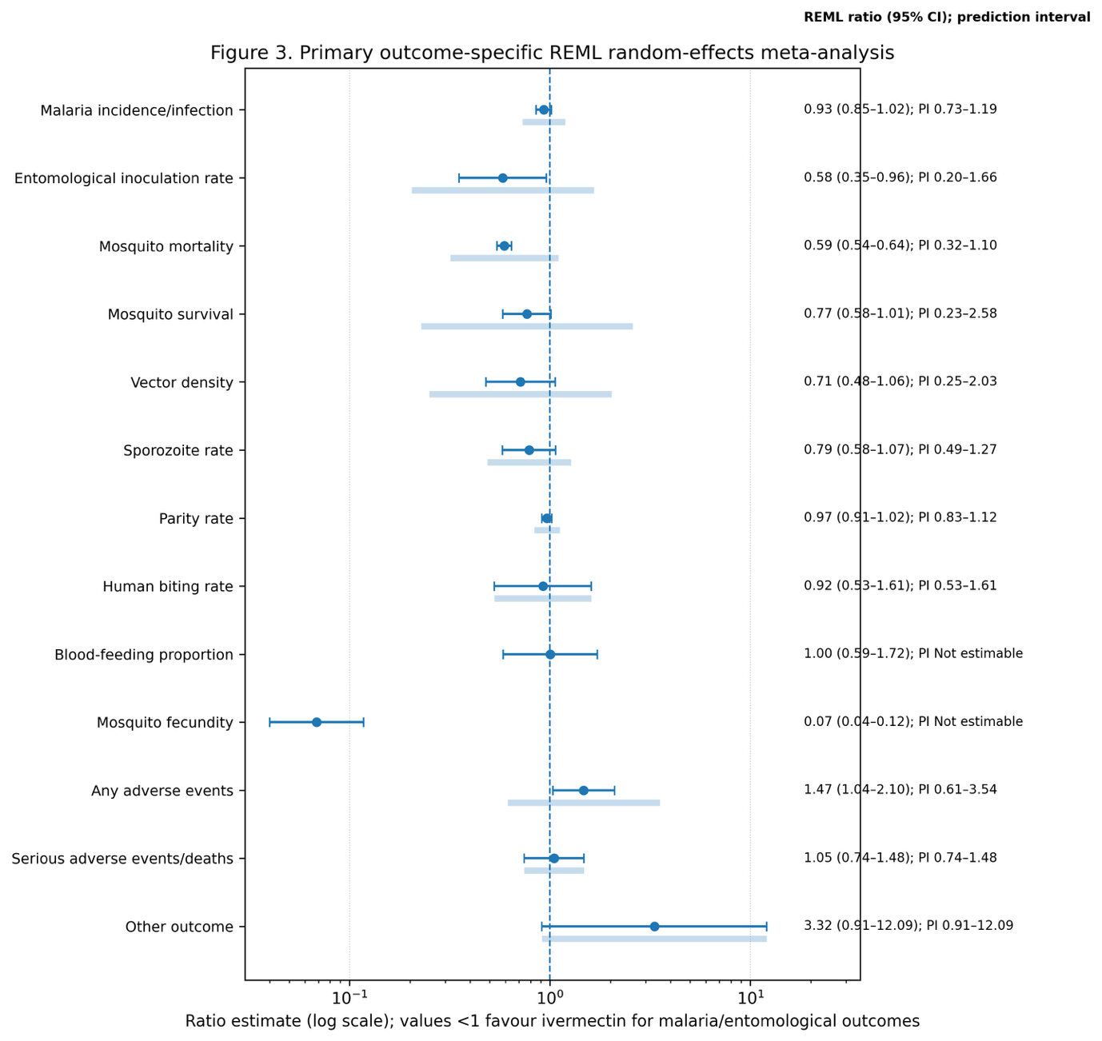
Figure 2. Primary outcome-specific REML forest plot

Note: Prediction intervals are additionally reported in Table 2 and should be interpreted alongside pooled estimates to assess generalisability across future transmission settings. See Appendix (Figure S6. p. 43) for individual forest plots.

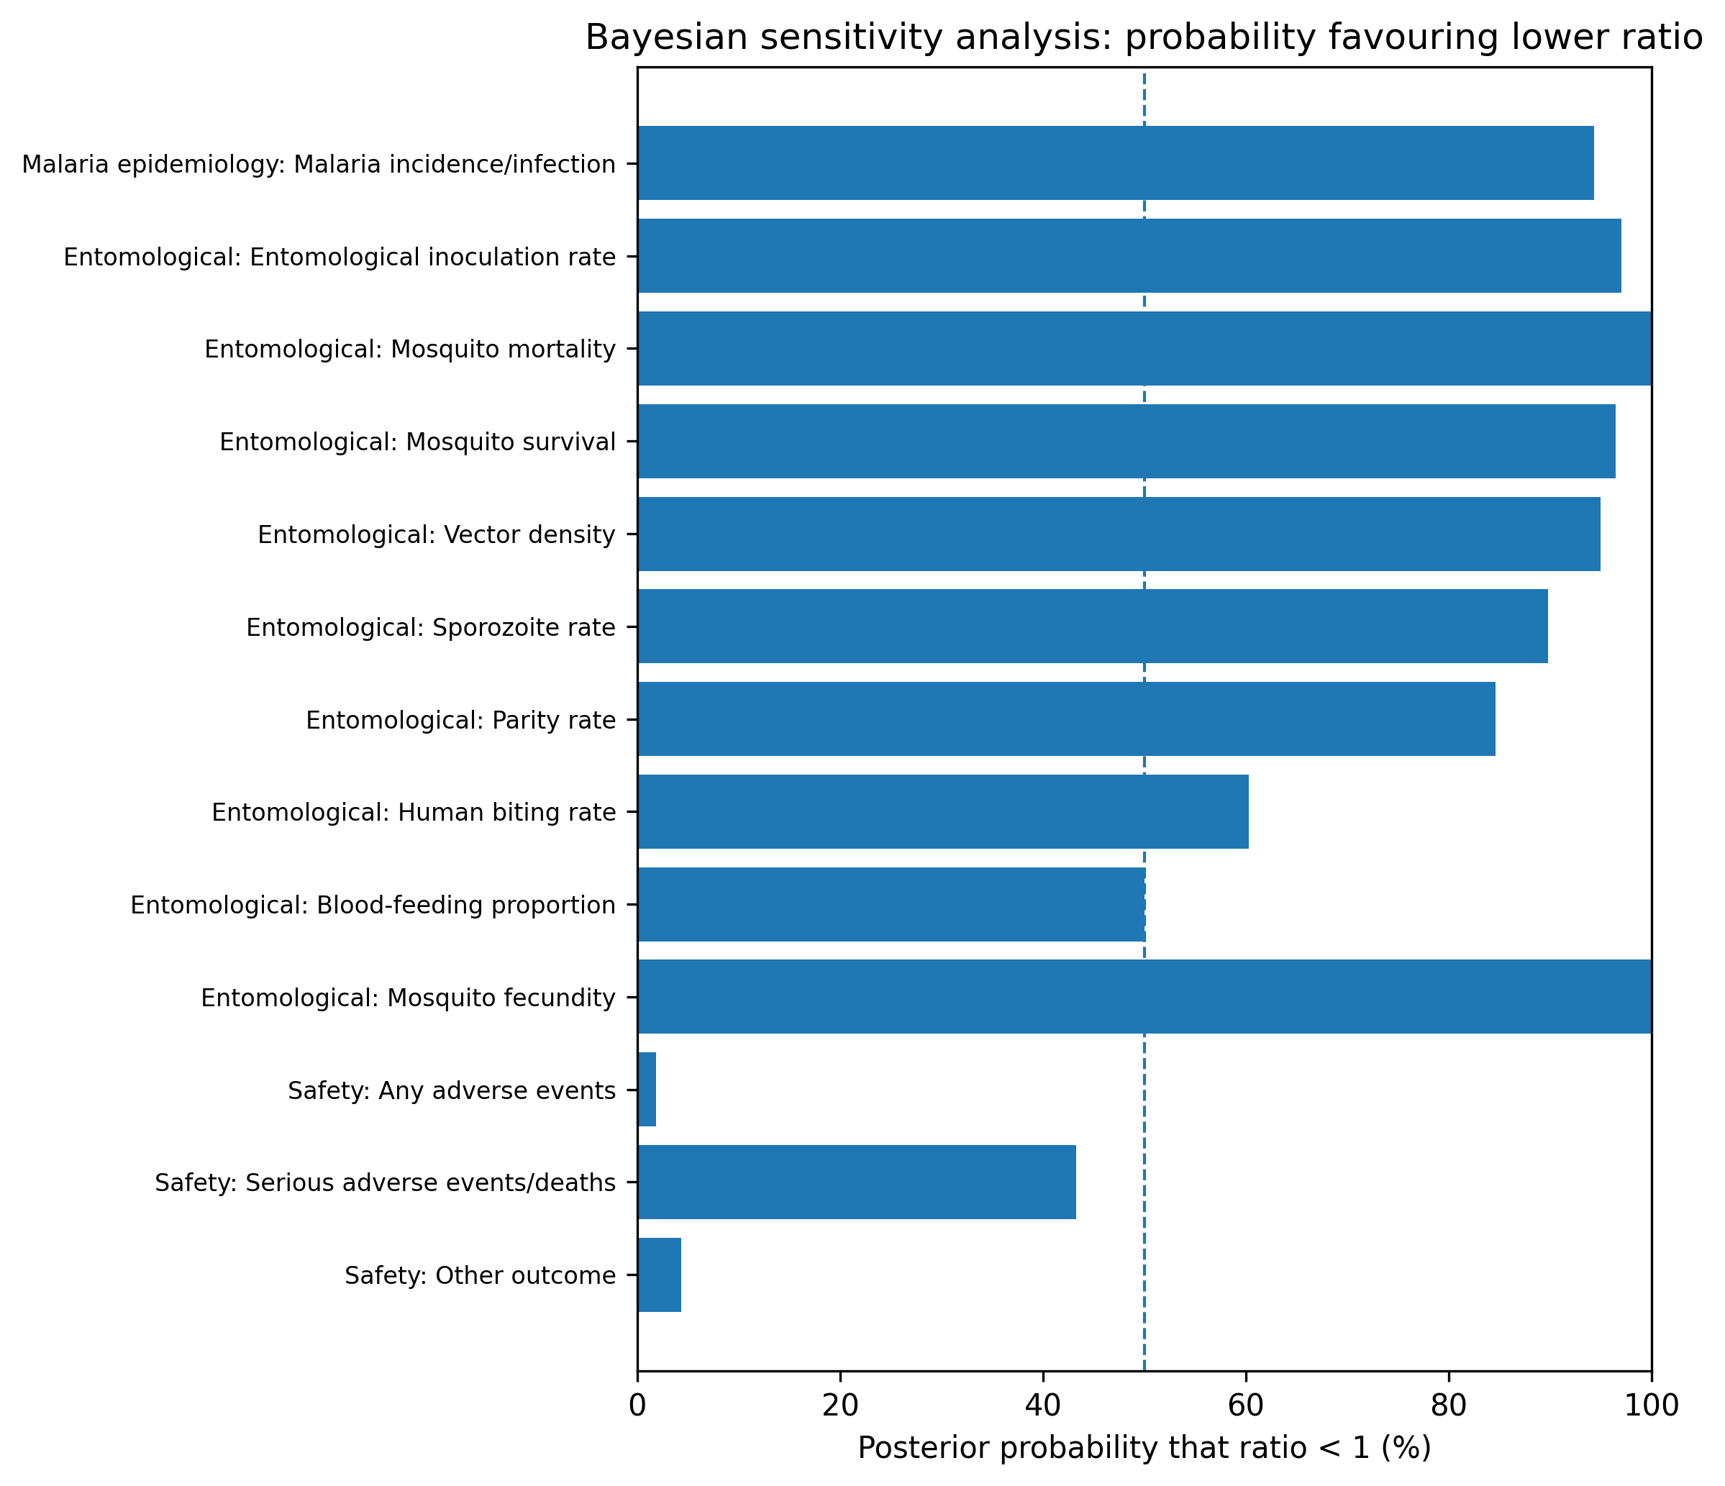
Figure 3. Bayesian sensitivity analysis: posterior probability that ratio <1

Note: Posterior probability that the ratio estimate is below 1. Posterior probabilities >0.95 were interpreted as strong evidence favouring ivermectin-associated reduction; probabilities between 0.80 and 0.95 were interpreted as suggestive evidence.

Table 1. Characteristics of included quantitative studies/platforms

Study/year | Country | Design | Intervention/regimen | Co-intervention/comparator | Median coverage (%) | Domains | Outcomes | Estimates
Alout et al., 2014 | Burkina Faso | Field entomology (pre/post around single ivermectin MDA; paired treated vs co... | IVM + Albendazole (ALB); IVM-1*150; Single dose (ivermectin 150 µg/kg) as per NTD MDA; ... | Albendazole | 84.0 | Entomological | Mosquito survival | 3
Alout et al., 2014 | Senegal | Field entomology (pre/post around single ivermectin MDA; paired treated vs co... | IVM + Albendazole (ALB); IVM-1*150; Single dose (ivermectin 150 µg/kg) as per NTD MDA; ... |  | 83.0 | Entomological | Mosquito survival; Sporozoite rate | 8
Chaccour C et al., 2025 | Kenya | Cluster RCT trial; community wide MDA; ivermectin vs albendazole | Ivermectin-only; 400; Single dose | Albendazole 400 mg used as active control in comparator c... |  | Malaria epidemiology; Safety | Malaria incidence/infection; Serious adverse events/deaths; Any adverse events | 5
Chaccour C et al., 2025 | Mozambique | Cluster RCT controlled trial; three-arm parallel-group open-label, assessor-b... | Ivermectin-only (combined); 400; Single dose | Albendazole 400 mg used as control in comparator arm; sta... | 48.0 | Malaria epidemiology; Safety | Malaria incidence/infection; Any adverse events; Serious adverse events/deaths | 5
Dabira et al., | The Gambia | Cluster RCT trial (nested cross-sectional surveys); investigators blinded to ... | IVM + Dihydroartemisinin–piperaquine (DP); 300–400; 3-day regimen | DHA–piperaquine | 82.9 | Entomological; Malaria epidemiology | Mosquito mortality; Malaria incidence/infection; Parity rate; Vector density; Sporozoit... | 12
Derua et al., 2015 | Tanzania | Randomised placebo controlled feeding experiment; volunteer-blinded and asses... | Ivermectin-only; 150–200; Single dose (height-based dosing) |  |  | Entomological | Blood-feeding proportion; Mosquito fecundity; Mosquito survival | 4
Foy et al., 2019 | Burkina Faso | Cluster RCT, parallel-group, single-blind (outcome assessor) trial; 8 village... | Ivermectin-only (repeated); 150–200; Single dose repeated | Albendazole baseline both arms | 75.0 | Malaria epidemiology; Safety; Entomological | Malaria incidence/infection; Any adverse events; Serious adverse events/deaths; Parity ... | 16
Pretorius 2024 | Guinea-Bissau | Cluster randomised trial (adjunctive ivermectin MDA); thesis appendix cluster... | DP + ivermectin vs DP; 300; 3-day regimen | DHA–piperaquine |  | Entomological | Vector density; Parity rate; Sporozoite rate; Entomological inoculation rate | 18
Smit et al., 2018 | Kenya | Randomised, double blind, placebo controlled, three-arm trial | IVM + Dihydroartemisinin–piperaquine (DP); Placebo; IVM-3*300; +1 more; Three consecuti... | Dihydroartemisinin–piperaquine (DP) 3 days |  | Entomological; Safety | Mosquito mortality; Serious adverse events/deaths; Any adverse events; Other outcome | 18
Smit et al., 2019 | Kenya | Randomised, double blind, placebo controlled, three-arm trial | IVM + Dihydroartemisinin–piperaquine (DP); IVM-3*600; IVM-3*300; Three consecutive dail... | Dihydroartemisinin–piperaquine (DP) 3 days |  | Entomological | Mosquito mortality | 12
Somé et al., 2025 | Burkina Faso | Phase 3, double blind, placebo controlled, cluster-randomised, parallel-group... | Ivermectin + Seasonal Malaria Chemoprevention (SMC); 300; 3-day regimen | SMC (children 3–59 months) | 68.0 | Entomological; Malaria epidemiology; Safety | Mosquito survival; Entomological inoculation rate; Human biting rate; Malaria incidence... | 11
Soumare et al., 2022 | The Gambia | Cluster RCT (MDA IVM+DP vs control) | IVM + Dihydroartemisinin–piperaquine (DP); 300–400 (per day) ×3d; 3-day regimen | DHA–piperaquine | 82.9 | Entomological | Parity rate; Vector density; Human biting rate; Sporozoite rate; Entomological inoculat... | 59
Sylla et al., 2010 | Senegal | Field entomology pre/post with control village (community wide ivermectin MDA... | Ivermectin (IVM); IVM-1*150; Single dose per annual MDA |  | 84.2 | Entomological | Mosquito survival | 4

Note: See Appendix (Table S3, p. 7) for full details and references.
Table 2. Primary outcome-specific REML random-effects meta-analysis results
Domain | Outcome | Studies | Estimates | Ratio (95% CI) | Prediction interval | tau² | I² (%) | p heterogeneity
Malaria epidemiology | Malaria incidence/infection | 5 | 19 | 0.93  (0.85–1.02) | 0.73–1.19 | 0.014 | 57.8 | <0.001
Entomological | Entomological inoculation rate | 5 | 9 | 0.58  (0.35–0.96) | 0.20–1.66 | 0.220 | 46.8 | 0.058
Entomological | Mosquito mortality | 4 | 69 | 0.59  (0.54–0.64) | 0.32–1.10 | 0.099 | 97.2 | <0.001
Entomological | Mosquito survival | 4 | 19 | 0.77  (0.58–1.01) | 0.23–2.58 | 0.364 | 97.2 | <0.001
Entomological | Vector density | 3 | 12 | 0.71  (0.48–1.06) | 0.25–2.03 | 0.244 | 58.8 | 0.005
Entomological | Sporozoite rate | 4 | 9 | 0.79  (0.58–1.07) | 0.49–1.27 | 0.036 | 24.7 | 0.224
Entomological | Parity rate | 4 | 11 | 0.97  (0.91–1.02) | 0.83–1.12 | 0.005 | 80.7 | <0.001
Entomological | Human biting rate | 2 | 2 | 0.92  (0.53–1.61) | 0.53–1.61 | 0.000 | 0.0 | 0.770
Entomological | Blood-feeding proportion | 1 | 1 | 1.00  (0.59–1.72) | Not estimable | 0.000 | 0.0 | -
Entomological | Mosquito fecundity | 1 | 1 | 0.07  (0.04–0.12) | Not estimable | 0.000 | 0.0 | -
Safety | Any adverse events | 5 | 11 | 1.47  (1.04–2.10) | 0.61–3.54 | 0.167 | 68.2 | <0.001
Safety | Serious adverse events/deaths | 4 | 9 | 1.05  (0.74–1.48) | 0.74–1.48 | 0.000 | 0.0 | 0.846

Note: Ratios below 1 indicate reduced malaria burden or reduced entomological transmission potential. For safety outcomes, ratios above 1 indicate more adverse events. See Appendix (Figure S6. p. 43) for individual domain forest plots.
Table 3. GRADE/certainty assessment by outcome
Domain | Outcome | Studies | Effects | Effect estimate | Prediction interval | Certainty
Entomological | Blood-feeding proportion | 1 | 1 | 1.00  (0.59–1.72) | Not estimable | Very low
Entomological | Entomological inoculation rate | 5 | 9 | 0.58 (  0.35–0.96) | 0.20–1.66 | Low
Entomological | Human biting rate | 2 | 2 | 0.92  (0.53–1.61) | 0.53–1.61 | Very low
Entomological | Mosquito fecundity | 1 | 1 | 0.07 (0.04–0.12) | Not estimable | Very low
Entomological | Mosquito mortality | 4 | 69 | 0.59  (0.54–0.64) | 0.32–1.10 | Low
Entomological | Mosquito survival | 4 | 19 | 0.77  (0.58–1.01) | 0.23–2.58 | Very low
Entomological | Parity rate | 4 | 11 | 0.97  (0.91–1.02) | 0.83–1.12 | Low
Entomological | Sporozoite rate | 4 | 9 | 0.79  (0.58–1.07) | 0.49–1.27 | Low
Entomological | Vector density | 3 | 12 | 0.71  (0.48–1.06) | 0.25–2.03 | Low
Malaria epidemiology | Malaria incidence/infection | 5 | 19 | 0.93  (0.85–1.02) | 0.73–1.19 | Low
Safety | Any adverse events | 5 | 11 | 1.47  (1.04–2.10) | 0.61–3.54 | Low
Safety | Serious adverse events/deaths | 4 | 9 | 1.05  (0.74–1.48) | 0.74–1.48 | Low

Note: Certainty was downgraded for inconsistency (substantial heterogeneity), imprecision (wide confidence or prediction intervals, sparse data), and indirectness (entomological surrogate outcomes rather than direct malaria burden outcomes).

